SOFTWARE TESTING METHODOLO HW9: TDI - Set up environment and application

Test Host: Digital Machine

Remote Address: <http://changcode.com>

Current Stack: Ubuntu + Nginx

pip wasn’t be installed

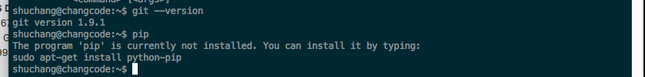

Test plan:

1. Setup all python environment including: django, Selenium, firefox, etc.

1.1 Install pip3

1.2 Through pip3 install django

1.3 Download todo project

1.4 Install selenium

1.5 Install firefox

I put all setup process into unit test class, running result and code like this:

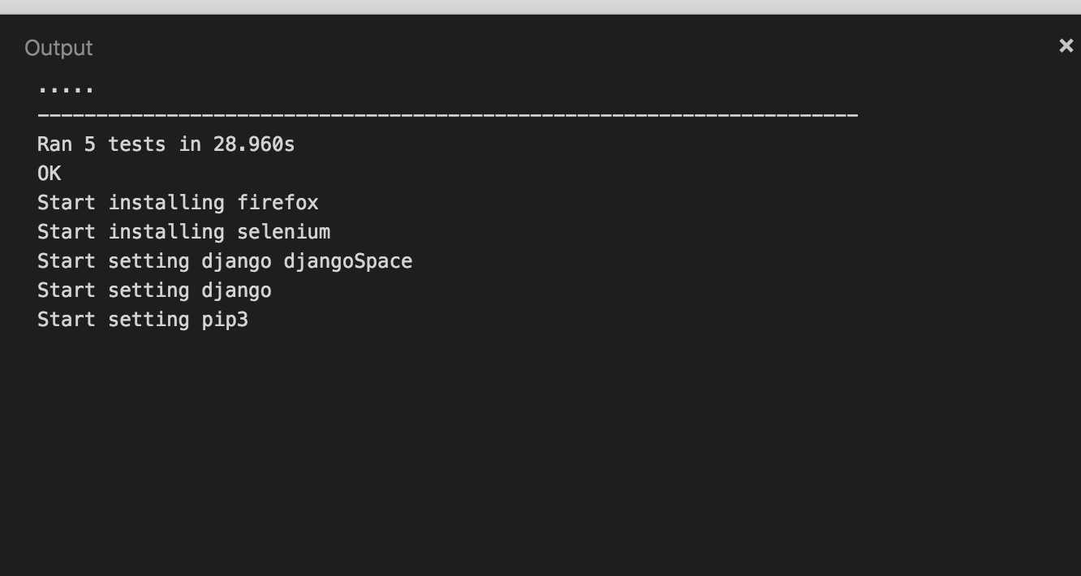

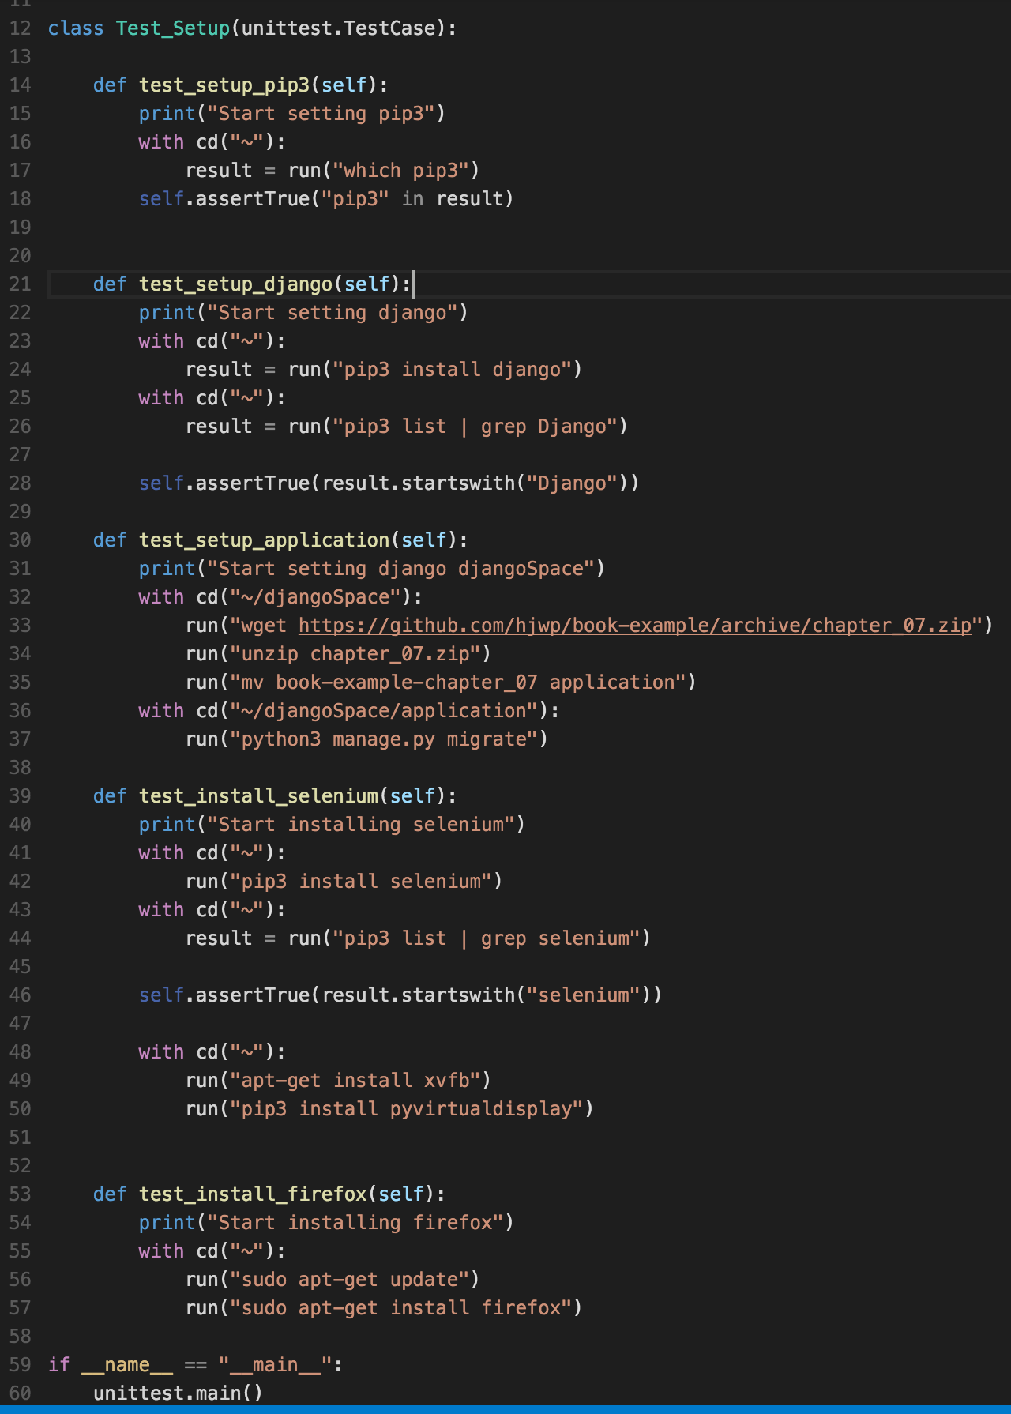

2. Start unit test in well configured remote environment:

2.1 test the user is myself:shuchang

2.2 verify python3 is installed

2.3 verify pip3 is installed

2.4 verify git is installed

2.5 verify django is installed

2.6 verify project is well configured

2.7 verify selenium is installed

2.8 verify firefox is installed

2.9 function test in project start

2.10 additional test python is running

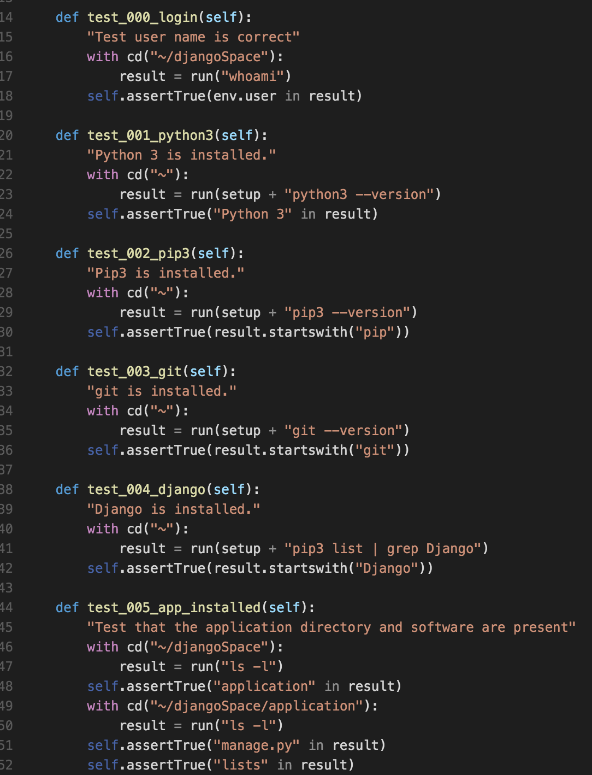

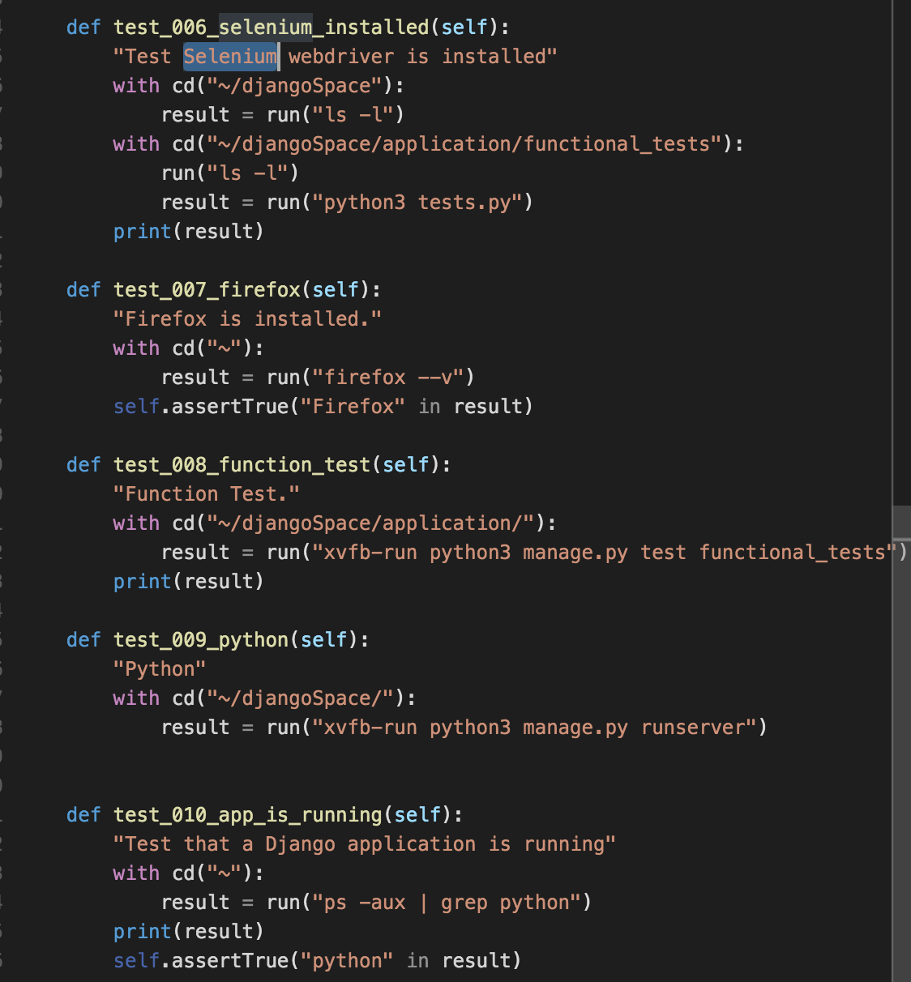

The final running result:

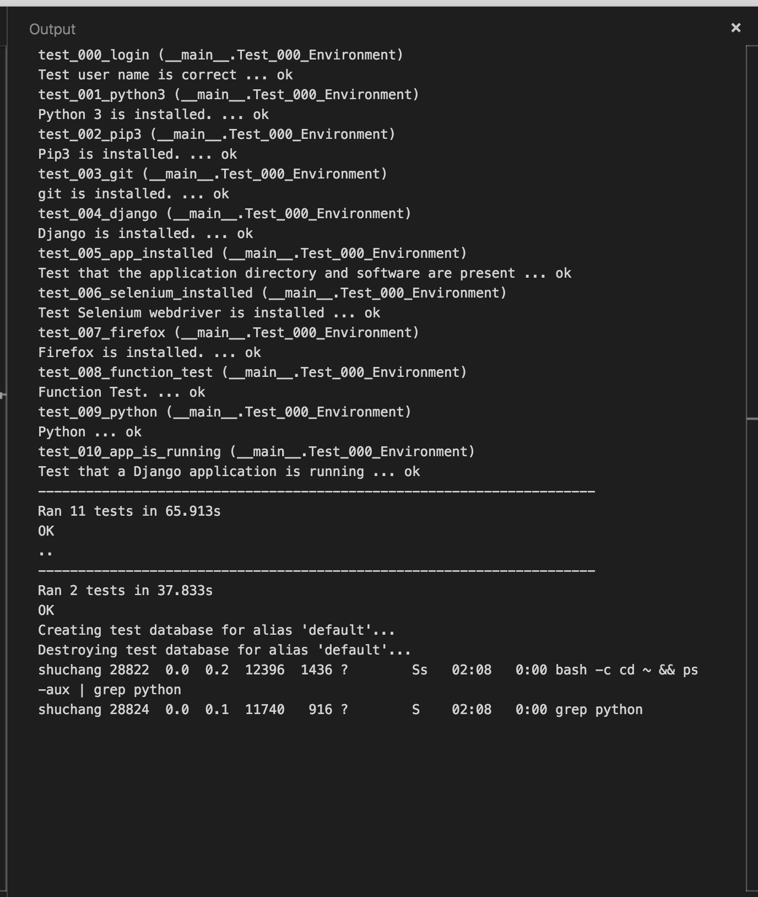

3.In the todo django project, the test file including:

There needs some configuration on web driver, set up display, then start testing.

